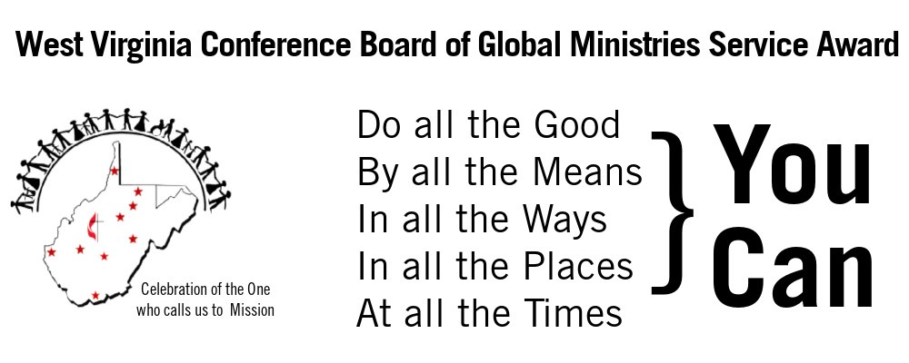
Please check one: ____Clergy ____Laity ____Group Information about Nominee:
Name:___________________________________________________________________
Address__________________________________________________________________
City:___________________________________________State:___________Zip:_______ Telephone Number( )____________Email:____________________________________ Church/Charge___________________________District___________________________
Name of mission/service project that is supported: ________________________________
Mailing Address of mission/service Project:____________________________________________ City:___________________________________________State:___________Zip:_______
Email of contact or website (if available)_________________________________________

This award is to honor the work of ministry with any individual or group involved in aiding any mission/service project by being the hands of Christ to a hurting community. It is a way to say thank you for all the individual or group does to represent Christ in the community.
Please provide the following information for your nominee:
- Tell how the nominee(s) is involved in mission/service to the community. __________
______________________________________________________________________
______________________________________________________________________
- How are people being transformed by this work?_______________________________
______________________________________________________________________
______________________________________________________________________
- How does this mission and the work of the nominee(s) provide hope to their community? ______________________________________________________________________
______________________________________________________________________
______________________________________________________________________
- Please add any other comments you feel important:_____________________________
______________________________________________________________________
______________________________________________________________________
______________________________________________________________________
Global Ministries Service Award Nomination Form page 2

Person making nomination:______________________________Position________________
Address:____________________________________________________________ City:________________________________State:____________ZIP:___________
Telephone:( )________________________Email__________________________

Please submit this form by April 30 to
Judy Raines, Chair of Global Ministries
1624 Ohio Street
Bluefield, WV 24701

If you have any questions please contact Judy Raines: denraines@frontier.com 304-327-6956
___________________________________________________________________
West Virginia Conference Global Ministries: Celebration of the One who calls us to mission

