2023 Day of Remembrance Offering

When you give to the Day of Remembrance Offering, you not only remember someone who faithfully served as a pastoral leader, you contribute to that person’s pastoral legacy.

This special offering is designated to benefit the Ministerial Education Fund (MEF), paving the way for continued clergy leadership within the West Virginia Conference. This year, the MEF is providing grants for 20 students, so that the financial burden of a seminary education will be reduced. Because of the MEF, these men and women avoid debt as they pursue their calling to be clergy leaders.

Through your generosity, the West Virginia Conference continues to deeply invest in the theological education of its clergy leaders, whether through seminary, the Course of Study, or continuing education.

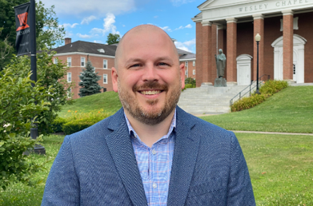
Jonathan Acord –
Director of Religious and Spiritual Life, West Virginia Wesleyan College
I am extremely grateful to God for the West Virginia Conference and Ministerial Education Fund, which have provided loving support throughout my education at United Theological Seminary. Thanks to your generous gifts, I was able to commit to being a full-time student without my family being overwhelmed by the financial stress of seminary. Thank you for giving so that individuals like me may be better positioned to serve in the mission and ministry of the triune God. You exemplify what it means for The United Methodist Church to be connectional.
Katie Knotts - pastor of the Williamsburg Charge in the Greenbrier Wesleyan District
I am incredibly grateful for the opportunity!
God has been so faithful all along this journey, and swings doors wide open when it comes to next steps that I really seem to have no choice but to walk through—the MEF being the key and means of grace to open the door.

Please honor a memory by generously planting seeds for growth
by your gift to the Ministerial Education Fund through the
Day of Remembrance Offering.
2023 Day of Remembrance Offering

When you give to the Day of Remembrance Offering, you not only remember someone who faithfully served as a pastoral leader, you contribute to that person’s pastoral legacy.

This special offering is designated to benefit the Ministerial Education Fund (MEF), paving the way for continued clergy leadership within the West Virginia Conference. This year, the MEF is providing grants for 20 students, so that the financial burden of a seminary education will be reduced. Because of the MEF, these men and women avoid debt as they pursue their calling to be clergy leaders.

Through your generosity, the West Virginia Conference continues to deeply invest in the theological education of its clergy leaders, whether through seminary, the Course of Study, or continuing education.

Jonathan Acord –
Director of Religious and Spiritual Life, West Virginia Wesleyan College
I am extremely grateful to God for the West Virginia Conference and Ministerial Education Fund, which have provided loving support throughout my education at United Theological Seminary. Thanks to your generous gifts, I was able to commit to being a full-time student without my family being overwhelmed by the financial stress of seminary. Thank you for giving so that individuals like me may be better positioned to serve in the mission and ministry of the triune God. You exemplify what it means for The United Methodist Church to be connectional.
Katie Knotts - pastor of the Williamsburg Charge in the Greenbrier Wesleyan District
I am incredibly grateful for the opportunity!
God has been so faithful all along this journey, and swings doors wide open when it comes to next steps that I really seem to have no choice but to walk through—the MEF being the key and means of grace to open the door.

Please honor a memory by generously planting seeds for growth
by your gift to the Ministerial Education Fund through the
Day of Remembrance Offering.

