Boy Scout Registration

https://scoutingevent.com/615-CircuitRider33#

Options

Bikes
History of the Mill
Climbing Wall
Stem

United Methodist Men Registration

https://scoutingevent.com/615-CircuitRider33#

Jackson Mill Lodge
Single $ 260.00 each
Double $ 240.00 each

Cabin $ 207 each

Dormitory $ 140 each

This price includes meals

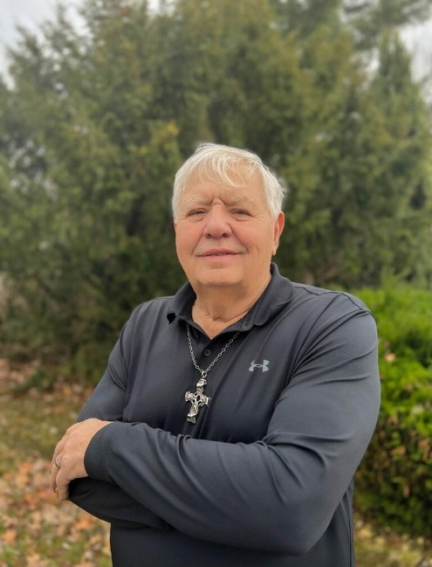

Mark K. Dehority
President - North Central Jurisdiction United Methodist Men.
Called to be the son, husband, father, brother, leader, follower, and disciple God planned me to be. Called to help other men to answer their calls, by equipping servant leaders and discipling men.
Ten-year Deployed Staff for the General Commission on United Methodist Men. Twenty-years serving the United Methodist Men at almost every level. Strong background and education in organizational development and team-based improvement.
A flawed individual trying to surrender to God’s will.
West Virginia United Methodist Men
Annual Retreat

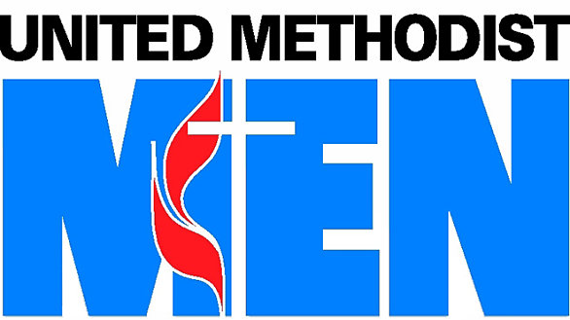

Jackson Mill
33rd Circuit Rider Event

September 8, 9,10, 2023

