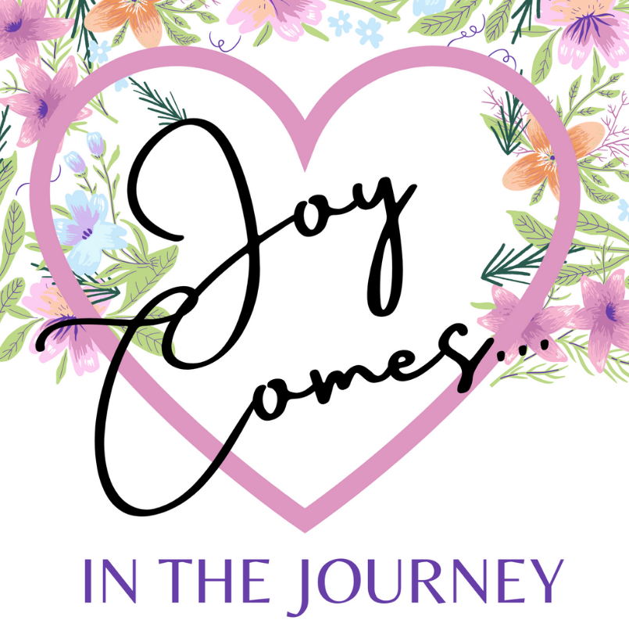

In Living Well

Saturday, July 22, 2023

9 a.m. - 2 p.m.
3rd Annual “Joy Comes…” FREE Women’s Event
All Welcome at Bethel Outdoor Pavilion
1300 Broadford Road, Mountain Lake Park, MD
Keynote speaker: Amy Carroll
Author/speaker/writer for Proverbs 31 Ministries and cohost for the podcast Grit ‘n’ Grace.

Register by using this QR code: (or call Robin at 304-789-2219).

