Local Church Self-Study

Church Name: ________________________
Pastor: ______________________________
District: _____________________________
Address: _____________________________
____________________________________

Our Mission is to . . . DISCOVER
DEVELOP
DEPLOY
passionate spiritual leaders who make disciples of Jesus Christ for the transformation of the world
Table of Contents

 | Page
Mission . . . . . . . . . . . . . . . . . . . . . . . . . . . . . . . . . . . . . . . . . . . . . . . . . . . . . . . . . . . | 3
Overview & Instructions . . . . . . . . . . . . . . . . . . . . . . . . . . . . . . . . . . . . . . . . . . . . . | 4
History & Description . . . . . . . . . . . . . . . . . . . . . . . . . . . . . . . . . . . . . . . . . . . . . . . | 5
Demographics & Statistics . . . . . . . . . . . . . . . . . . . . . . . . . . . . . . . . . . . . . . . . . . . . | 6
Community Study . . . . . . . . . . . . . . . . . . . . . . . . . . . . . . . . . . . . . . . . . . . . . . . . . . | 8
MissionInsite . . . . . . . . . . . . . . . . . . . . . . . . . . . . . . . . . . . . . . . . . . . . . . . . . . . . . . | 9
Documents & Discipleship . . . . . . . . . . . . . . . . . . . . . . . . . . . . . . . . . . . . . . . . . . . | 11
Questionnaire . . . . . . . . . . . . . . . . . . . . . . . . . . . . . . . . . . . . . . . . . . . . . . . . . . . . . . | 12
Leadership Questions . . . . . . . . . . . . . . . . . . . . . . . . . . . . . . . . . . . . . . . . . . . . . . . . | 18
Next Steps . . . . . . . . . . . . . . .. . . . . . . . . . . . . . . . . . . . . . . . . . . . . . . . . . . . . . . . . . | 19
Resources . . . . . . . . . . . . . . . . . . . . . . . . . . . . . . . . . . . . . . . . . . . . . . . . . . . . . . . . . | 20

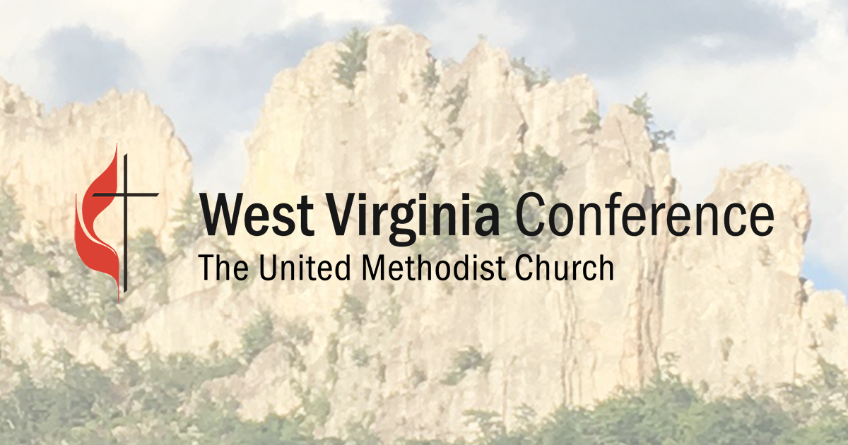

Mission

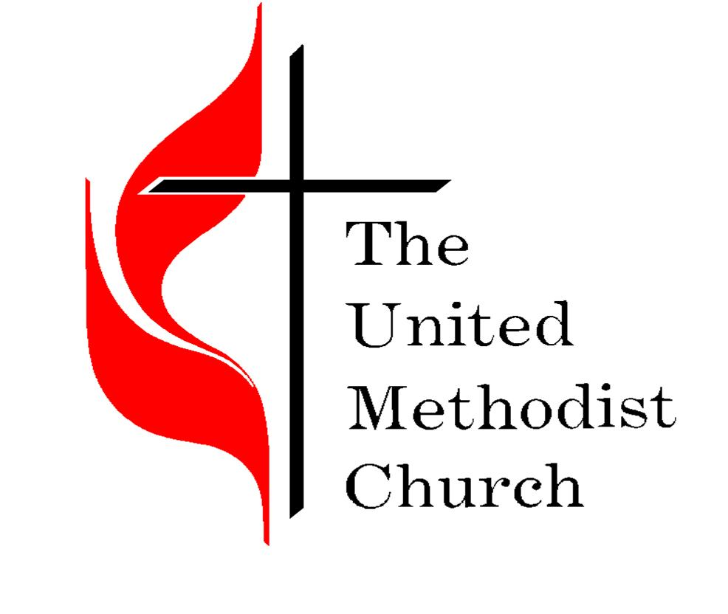
The mission of the United Methodist Church is to make disciples of Jesus Christ for the transformation of the world.

This is what we do. We make disciples.

Our mission statement is directly influenced by the words of Christ found in Matthew 28:

Jesus came near and spoke to them, “I’ve received all authority in heaven and on earth. Therefore, go and make disciples of all nations, baptizing them in the name of the Father and of the Son and of the Holy Spirit, teaching them to obey everything that I’ve commanded you. Look, I myself will be with you every day until the end of this present age.” – Matthew 28:18-20, CEB

Everything we do, all our activities and resources should be focused in making disciples of Jesus.

This is the foundation upon which we build and the lens through which we encourage you to view all the following self-study data and research.

What can you learn about your church and your mission field to help you better make disciples?

There are many chapters in the book of your church and its ministry.

Some of those chapters are filled with joy and fruitful ministry. Other chapters contain challenges, pain, and maybe even loss.

All of those chapters make up the story of your church.

This process is NOT about writing a new book of your church . . .

. . . just discerning the next chapter God is calling you to write!

Overview & Instructions

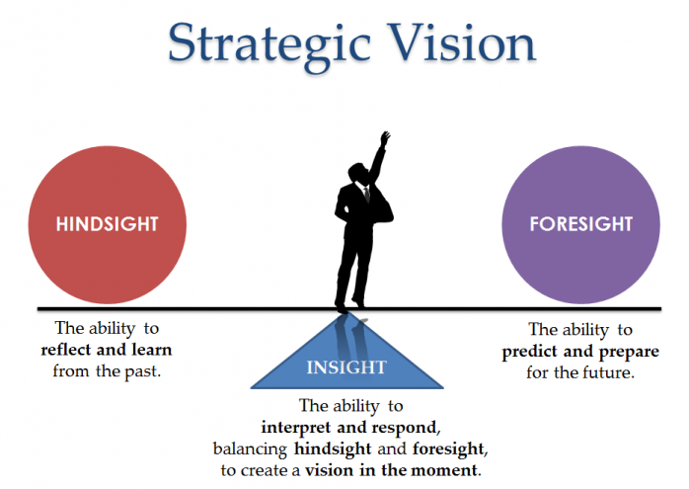
One of the best ways for a church to move forward into God’s vision for the future of their ministry is to have a clear picture of where they have been and where the church is today.

Instructions
- Gather a team to help you complete this self-study. The team should be made up of ministry leaders, long and short-term members, and other key individuals. (Use the make up of your church as a guide.) The pastor(s) needs to be involved and on this team but should not try to do all the work themselves. Collecting the information is part of the learning.
- Consider dividing up sections of the self-study among the team and assigning deadlines for completion.
- Complete all aspects of the self-study and then make arrangements to share the key learnings with your church’s Administrative Board. They will need time to process the information prior to having them complete the Leadership Questions on page 18.
- Most churches can complete the entire self-study in three to four months. This allows for time to pull all the pieces back together and share the information as appropriate.
- While this self-study is focused a lot on statistics, numbers, data, and information—that does not mean you should “turn off God” while you do this work. We encourage you to make this a prayerful, Spirit-filled process. Spend time in God’s Word together and prayer before, during and after you do this work.
History & Description

Read Acts 2—Pentecost
Pentecost is often referred to as the “birth of the church.” What stands out to you about these verses? What do phrases such as “they were all together in one place,” or “He poured out this Spirit,” or “The Lord added daily to the community” mean to your ministry today?
- Write a brief history of your church/congregation. [one-page front and back max] Be sure to include the origin story of the church. Include those event that contributed to periods of growth or decline in attendance. Write in a factual style, avoiding the temptation to exaggerate information or inject personal commentary. (Not just a facilities history, focus more on the ministry.)

- List dates and provide descriptions for any building construction, major renovations, land acquisitions, or leasing of facilities. List the amount of acreage you own, lease or rent, the square footage of buildings, and the total number of parking spaces. (distinguishing between off-street and street parking)

- List any formal ties or major connections to other organizations or associations. State how the congregation views and interacts with these groups.

- Provide a list of all full and part-time program staff positions for the last twenty years. Give the dates of tenure and state the reason why they left—if permissible.

- Provide a list of all people who currently oversee specific areas of ministry. Create an organizational chart that reflects your current structure. Be sure all committees, ministries, teams, groups, connected to the church are included.

Demographics & Statistics

Read Matthew 14:13-21; Mark 8:1-10; and Numbers 1:2
People matter to God. The Bible is full of statistics and numbers. We tend to see them only has numbers and too many churches and Christians have developed a fear of data. Every number is important to God, because they represent people! How do you feel about numbers and statistics? Pray to God now to open you to see what He sees.
- Go to the website umdata.org
  - click on the button that says “STATS”
  - Click on the “Charges/Churches” option listed on the left
  - under the Jurisdictions section select “Northeastern”
  - under the Conference section select “WEST VIRGINIA”
  - under the District section, click on the name of your district
  - find the name of your church on the list, and click on it
  - At the bottom of the Charts section on the left side of the page is a button which says, “Healthy Church Initiative Download” – click on it – an Excel workbook will download which you can save to your computer
  - You may want to share the total file, or at least important sections of this data with key leaders in your church.
- Create charts showing information from 1990 to today for at least the following categories: (see example below)
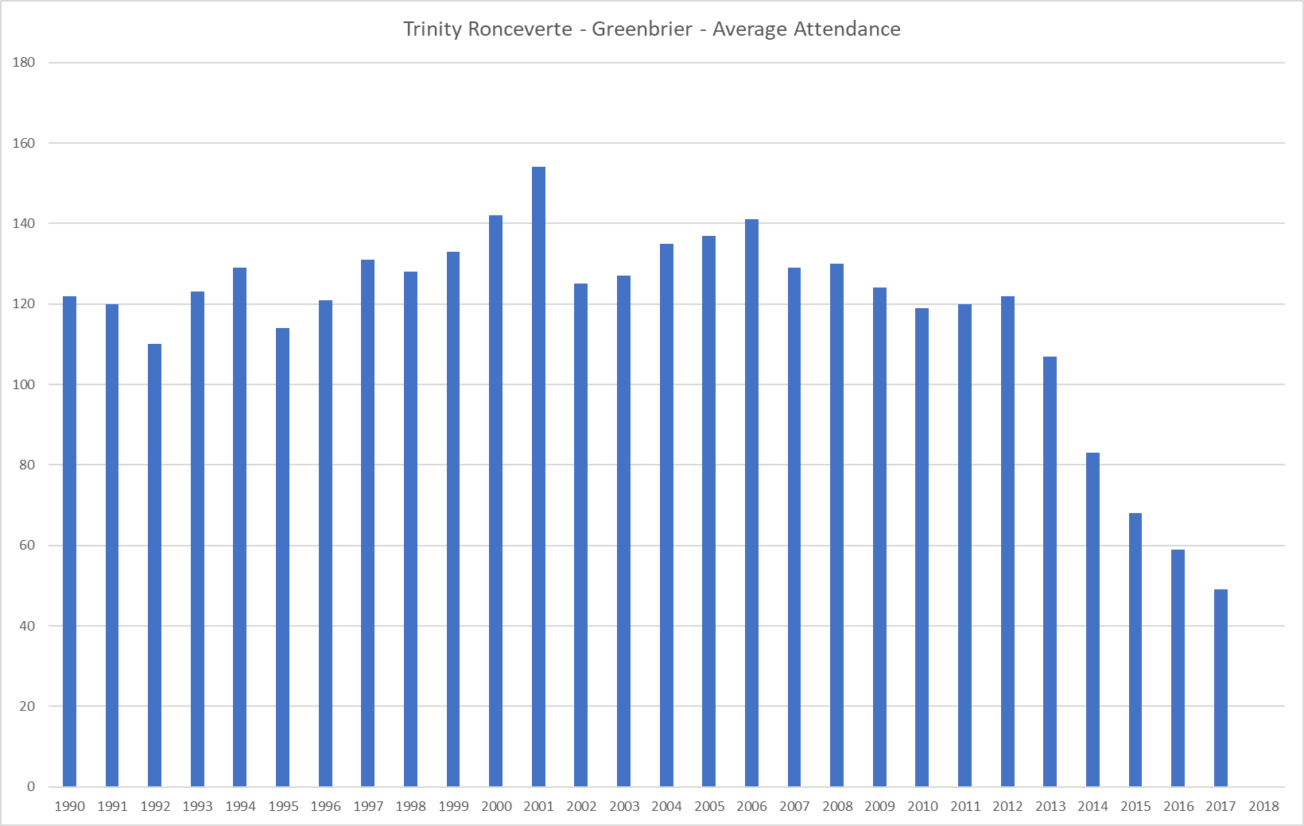
  - Average Attendance
  - Membership
  - Professions of Faith
  - Removed by Death
  - Baptisms

Demographics & Statistics

- Estimate the average age of the people participating in the regular activities of your church. State how this was determined.

- State the percentage of people who attend your worship services who also attend some type of Christian community—Sunday school class, small group meeting, Celebrate Recovery, other support groups, etc. Count each individual only once.

- Prepare a list of the number of current members or regular attenders who got involved in your church:
  - Prior to 1970
  - From 1971 – 1980
  - From 1981 – 1990
  - From 1991 – 2000
  - From 2000 – 2010
  - From 2011 – Present

- Without listing names, state the amount given by each of the top ten contributors on record in the last fiscal year. Total these amounts and state the percentage of giving this represents in relation to the total of all contributions.

- State the same information for the second ten contributors on record.

- State the total number of contributors to the church during the last fiscal year and the average amount given per contributor during that same time.

Community Study

“For where two or three are gathered in my name, I’m there with them.” – Jesus, Matthew 18:20
- Write a brief overview of the area and community in which the church is located and which you primarily serve. [Typically, 1-2 miles around the church building]

- Community Leader Interviews – talk to at least five different key leaders in your community. Examples: police chief; fire chief; school principle; business leader; social worker; school counselor; mayor or other official; chamber of commerce

(Please honor the time of the person you are talking to by limiting your conversation to 30 minutes or less.) Share the following with the person you are interviewing—in your words. “Our church is talking to community leaders such as yourself in order to better understand the community we feel God has called us to serve. Thank you for taking the time to speak with me today. I just have a few questions to ask. I’m going to take notes as we talk so we can compile all of our interviews.”

  - Based on your position in our community, what do you see as the top 2-3 needs of our community?
  - From your unique perspective, what do you know about our community that others might not know?
  - What would you like to see a local church do in order to improve our community?
  - What would you like to share with our church about our community?
MissionInsite
“Wherever you go, I’ll give you that land, as I promised Moses.” – Joshua 1:3
Read Connect with your community through PrayerWalking on the West Virginia Conference webpage posted 9/6/2018 in the News section.
You will need to have access to, and a basic understanding of, MissionInsite in order to complete this section of the self-study. Please visit the conference website [www.wvumc.org] and locate the MissionInsite page in order to learn more and register if needed.
- Go to the People Plot section. On the “What Would You Like to Do” page after you log into MissionInsite. (If you have not already done so, watch the video on how to upload people in your church into the MissionInsite system, and upload the Excel sheet as instructed.)
  - Choose your church from the dropdown list on the next page “Lets Decide Which Congregants You Want to Plot” – and click “Next”
  - On the “Now, Lets Decide How the Plots Should be Color Coded” page – Leave the “Legend By…” section on “None” and check the box “Show Labels” – and click “Next”
  - On the “Review and Summary” page – click on “Finish”
  - Zoom in on the map on the next page until you see your church and the names of people in your congregation.
  - On the left side of the page you should see an icon of a pen called, “Draw New Shape and Query” – when you click on it, you will be able to create a shape around where your congregation lives. IMPORTANT NOTES: 1) Try to keep your church in the approximate center of the shape; 2) Try to include most, but not all of your congregation in the shape—it is very common for some people to drive further than others to attend a church, keep your focus close to the building while working to include at least 80% of your people. 3) Don’t forget to close the shape by connecting the last point with the first point.
  - Once you have your shape, click on the “demographics” button at the bottom of the page. On the far right you should now see a “Demographics” section—under “Predefined” click on the dropdown next to “Select a predefined report” (Be sure to click on your shape so you are not running reports for a larger area. You will know because your shape will be shown on the report first page.)

MissionInsite

- Run the following reports: QuickInsite; ExecutiveInsite; FullInsite; ComparativeInsite; MinistryInsite Priorities; and ReligiousInsite Priorities.
  - Save a copy of these reports for you to have incase you need to print them again.
  - Print a copy of each report.
  - As you are reviewing all of the information contained within these reports, be sure to answer these questions about your mission field (the area of the shape you created):
    - What is the total population? Is that population growing, declining, or staying flat. How does our church attendance trend compare to the population trend?
    - What are the racial-ethnic trends? Does our congregation represent our mission field?
    - What is the average age?
    - What is the average household income?
    - What percentage of households with children are single parent?
    - What are the percentages of White to Blue Collar? How does that compare to our church?
    - What are the percentages of each generation in our mission field? What are the percentages by generation of our congregation?
    - What percentage of people in our mission field are NOT active in a religious congregation or community?
    - What “Mosaic Segments” are we not reaching?
    - What percentage of our potential giving are we currently receiving?

- What are the top 3-5 things you learned from these reports that should influence your ministry in the next year?

Documents

The Lord replied, “Who are the faithful and wise managers whom the master will put in charge of his household servants, to give them their food at the proper time? Happy are the servants whom the master finds fulfilling their responsibilities when he comes. I assure you that the master will put them in charge of all his possessions.” – Jesus, Luke 12:42-44
- Gather the following documents:
  - Last two charge conference reports
  - Last two annual budgets and full financial statements, for the past two fiscal years, as well as the most recent financial report for this year (YTD). Be sure to include budget versus actual and balance sheets.
  - Sample bulletins and newsletters, for several different seasons if possible, at least six of each of them.
  - Any policy statements or policy manuals.
  - Other printed documents you feel would be helpful in providing insight into your church.

Discipleship

“Therefore, go and make disciples of all nations, baptizing them in the name of the Father and of the Son and of the Holy Spirit, teaching them to obey everything that I’ve commanded you. Look, I myself will be with you every day until the end of this present age.” – Jesus, Matthew 28:19-20
- What is the church’s intentional process for growing disciples?
- What indicators have you seen that this discipleship process is producing fruit?
- How does a new to this church person get engaged with the discipleship process?
- What are your next steps as a church in the area of discipleship?

Questionnaire
This material is based on a survey created by Bill Easum, and is used with his permission.

Parking
- Average attendance of largest worship service.
- Paved off-street parking spaces available (please count)
- 80% of total parking spaces
- Number of parking spaces needed. [divide (24) by 2 and compare to (26)
Small Groups
(15 people or less) These groups need to meet at least twice a month—Do not count Sunday school classes.
- Number of support / recovery groups
- Number of nurture groups
- Ministry teams
- Others (please identify)
- Number needed if you had one group for each 15 or so in worship.
Sanctuary
Do not estimate or take data from architect’s work—measure actual pew lengths and divide by 22 inches.
- Sanctuary total capacity
- 80% of capacity
- Average main service attendance

Questionnaire
This material comes from a survey created by Bill Easum, and is used with his permission.

Nursery & Children’s Ministry
- Nursery capacity (30 sq. ft. per child)
- 80% of capacity
- Average main service attendance in the nursery
- Number needed for 80%
- How many personnel in the nursery at main service?
- Is there a nursery for all church events?
- Are infants and toddlers separated?
- Are nursery policies given to parents?
- Are you currently using Safe Sanctuary guidelines?
- Do you have a plan to keep the nursery safe from harm or kidnapping?
- What type of check-in system are you using?
- Do the doors for all rooms throughout the church have clear glass windows, which are uncovered, so people can see into the room?
- How often are toys cleaned?
- How often are toys replaced?
- How many children are you averaging in each of the rooms weekly?
- How is the children’s ministry helping each child grow as a disciple?
- What is the church’s children-to-adults ratio?

Questionnaire
This material comes from a survey created by Bill Easum, and is used with his permission.

Sunday Worship
- What hours?
- Do you offer worship other than Sunday morning?
If so, what day and time?
- Do you offer worship on another site? If so, where? Day? Time?

Music
- What type of music are you using?
Service time: __________ Choir / Praise band / Other __________
Service time: __________ Choir / Praise band / Other __________
Service time: __________ Choir / Praise band / Other __________
Sunday School
- Number of adult Sunday school classes
- Average number of adults in Sunday school
- Average number of youth in Sunday school
- Average number of children in Sunday school
- How often do you start a new adult Sunday school class?
- When was the last time you started a new adult Sunday school class?

Questionnaire
This material comes from a survey created by Bill Easum, and is used with his permission.

- Are the area public schools growing, stable or declining? (Do not guess, have data to support your conclusions.)

- What is the percentage of the present debt service (annual mortgage payment) to the annual budget?

Signing
- Is there an adequate/attractive sign perpendicular to the street with worship times clearly visible (can you read them from a car driving the speed limit) to guide first-time guests?
- Are there clear/attractive signing inside the building to help people find their way? (focused on: nursery, rest rooms, and worship space)
- Are at least 10% of the parking spaces designated for first-time guests?
- Number of pastors over the past 20 years.
- Average number of adults in worship who are 60 years of age or older.

Questionnaire
This material comes from a survey created by Bill Easum, and is used with his permission.

Paid Staff
- Number of full-time staff (other than the lead pastor)
- Number of part-time staff.
- Number of meetings the pastor attends in a month.
First-Time Guests
- Average number of first-time guest families each week. [A good rule is: the number of new-here guests per year should be equal to the average number of attendees in worship.]
- Are these families added to the church email or mailing list?
- Number of hours between a first-time guest attending a service and being contacted by the church.
- How many spiritual leaders does the church have?
- How many new leaders are raised up each year?
- What is the church’s intentional plan to grow both current and new leaders?

- How many people are involved in hand-on ministry each week?
- What percentage of those who call this their church home are serving?
- How many first-time serving people did you have last year?

Questionnaire
This material comes from a survey created by Bill Easum, and is used with his permission.

Put aside all bitterness, losing your temper, anger, shouting, and slander, along with every other evil. Be kind, compassionate, and forgiving to each other, in the same way God forgave you in Christ.  Ephesians 4:31-32 | - Has the church had any major conflicts in the past 20 years? If so, is the conflict resolved? Please comment briefly (as if to someone outside your church)

Leadership Questions

“Do nothing out of selfish ambition or vain conceit, but in humility consider others better than yourselves. Each of you should look not only to your own interests, but also to the interests of others.” – Apostle Paul, Philippians 2:3-4

Once you have completed all the previous questions and gathered all of the necessary documents and information—pull it together into a binder or some other form so you can share a copy with each person on your leadership team.

Give them some time, at least 30 days, to study the information and pray for God’s Spirit to provide discernment and wisdom concerning your church’s next steps.

Bring the leadership team back together and as a group answer the following questions:

- What are the 3-5 greatest strengths of this congregation, listed in priority order?
- What are the 2-3 most significant weaknesses/challenges of the church we need to address in the next 12 months?
- What three changes would we most like to see made in the church, in priority order, in order to best reach our mission field and make disciples of Jesus?
- Do the leaders want this congregation to grow significantly in the next five years? Why or why not?
- Are we as leaders willing to make the difficult decisions required for change and growth?

Next Steps
Need help? Not sure what to do next?
Ready to move into God’s vision for your ministry?
Contact your District Superintendent, your district lead team, or Ken Willard. Schedule a time to talk and dream.
Possible Next Steps
- As a leadership team, read one of the books listed in the Resources section and pray about how you might use the learning in your ministry.
- Engage with Readiness 360 (www.readiness360.org) to have your congregation complete the online survey to assess your readiness to grow your ministry. [There is a cost based on your average worship attendance.]
- Engage with a professional coach to help walk with you on this journey and provide resources and accountability.
- Form a team of leaders to intentionally learn and grow together over the next year using some of the resources listed on the following page.

Ken Willard
Director of Discipleship, Leadership and Congregational Vitality
West Virginia UMC Conference
kwillard@wvumc.org (636) 346-7172

Resources

7 Practices of Effective Ministry, Andy Stanley, Lane Jones, Reggie Joiner
10 Prescriptions for a Healthy Church, Bob Farr & Kay Kotan
Advanced Strategic Planning: A New Model for Church and Ministry Leaders, Aubrey Malphurs
Autopsy of a Deceased Church: 12 Ways to Keep Yours Alive, Thom S. Rainer
Bearing Fruit: Ministry with Real Results, Lovett H. Weems
Becoming a Welcoming Church, Thom S. Rainer
Beyond the First Visit: The complete guide to connecting guests to your church, Gary L. McIntosh
Canoeing the Mountains: Christian Leadership in Uncharted Territory, Tod Bolsinger
Church Growth Flywheel: 5 Practical Systems to Drive Growth at Your Church, Rich Birch
Clip In: Risking Hospitality in Your Church, Jim Ozier
Communicating for a Change: Seven Keys to Irresistible Communication, Andy Stanley
Courageous Leadership, Bill Hybels
Crucial Confrontations: Tools for Resolving Broken Promises, Violated Expectations, and Bad Behavior, Kerry Patterson, Joseph Grenny, Ron McMillan, and Al Switzler
Cure for the Common Church, Bob Whitesel
Deep and Wide: Creating Churches Unchurched People Love to Attend, Andy Stanley
Direct Hit: Aiming Real Leaders at the Mission Field, Paul D. Borden
Doing the Math of Mission: Fruits, Faithfulness and Metrics, Gil Rendle
Evangelism in the Small Membership Church, Royal Speidel
Five Practices of Fruitful Congregations, Robert Schnase
Fusion: Turning First-Time Guests into Fully-Engaged Members, Nelson Searcy
Gear Up! Nine Essential Process for the Optimized Church, Kay Kotan and Bob Farr
Get Their Name: Grow your church by building new relationships, Bob Farr and Kay Kotan
Good to Great: Why Some Companies Make the Leap…and Others Don’t, Jim Collins
How to Break Growth Barriers: Capturing Overlooked Opportunities for Church Growth, Carl F. George
I am a Church Member, Thom S. Rainer
Ignite: How to Spark Immediate Growth in Your Church, Nelson Searcy
Impact! Reclaiming the Call of Lay Ministry, Kay Kotan and Blake Bradford
It: How Churches and Leaders Can Get It and Keep It, Craig Groeschel
Just Say Yes!: Unleashing People for Ministry, Robert Schnase
Lasting Impact: 7 Powerful Conversations That Will Help Your Church Grow, Carey Nieuwhof
Lead Like Jesus: Lessons from the greatest leadership role model of all time, Ken Blanchard and Phil Hodges
Leadership Axioms: Powerful Leadership Provers, Bill Hybels
Leadership and the One-Minute Manager: Increasing Effectiveness Through Situational Leadership, Ken Blanchard, Drea Zigarmi, and Patricia Zigarmi

Resources

Leading Congregational Change: A Practical Guide for the Transformational Journey, Jim Herrington, Mike Bonem, and James H. Furr
Leading Change in the Congregation: Spiritual & Organizational Tools for Leaders, Gil Rendle
Managing Polarities in Congregations: Eight Keys For Thriving Faith Communities, Roy M. Oswald
Managing Transitions: Making the Most of Change, William Bridges
Membership to Discipleship: Growing mature disciples who make disciples, Philip Maynard
Ministry Nuts and Bolts: What They Don’t Teach Pastors in Seminary, Aubrey Malphurs
Not a Fan: Becoming a completely committed follower of Jesus, Kyle Idleman
Not Your Parents’ Offering Plate: A New Vision for Financial Stewardship, Clif J. Christopher
Obstacles in the Established Church: How Leaders Overcome Them, Sam Rainer
Our Iceberg Is Melting: Changing and Succeeding Under Any Conditions, John P. Kotter, Holger Rathgeber, and Peter Mueller
Overflow: Increase Worship Attendance & Bear More Fruit, Lovett H. Weems
Pastor on Track: Reclaiming Our True Role, Emanuel Cleaver III
Raising The Roof: The Pastoral to Program Size Transition, Alice Mann
Rebuilt: The Story of a Catholic Parish, Michael White
Remember the Future: Praying for the Church and Change, Robert Schnase
Renovate or Die: 10 Ways to Focus Your Church on Mission, Bob Farr & Kay Kotan
Rise: Bold Strategies to Transform Your Church, Cally Parkinson, Nancy Scammacca Lewis
Simple Church: Returning to God’s Process for Making Disciples, Thom Rainer
Small Church Checkup: Assessing Your Church’s Health and Creating a Treatment Plan, Kay Kotan
Start This, Stop That: Do the Things That Grow Your Church, Jim Cowart and Jennifer Cowart
Strategy Matters: Your Roadmap for an Effective Ministry Planning Retreat, Kay Kotan, Ken Willard
Stride: Creating a Discipleship Pathway for Your Church, Mike Schreiner & Ken Willard
The Advantage: Why Organizational Health Trumps Everything Else in Business, Patrick Lencioni
The Anatomy of Peace: Resolving the Heart of Conflict, Arbinger Institute
The Carpenter: Build a Winning Team, Jon Gordon
The Emotionally Healthy Church: A Strategy for Discipleship That Actually Changes Lives, Peter Scazzero
The Equipping Church, Sue Mallory
The Healthy Small Church: Diagnosis and Treatment for the Big Issues, Dennis Bickers
The Necessary Nine: Things Effective Pastors Do Differently, Bob Farr & Kay Kotan
The Purpose Driven Church: Every Church is Big in God’s Eyes, Rick Warren
Ultimately Responsible: When You’re In Charge of Igniting a Ministry, Sue Nilson Kibbey
Unbinding the Gospel: Real Life Evangelism, Martha Grace Reese
Winning on Purpose: How to Organize Congregations to Succeed in Their Mission, John E. Kaiser
Zero to 80: Innovative Ideas for Planting and Accelerating Church Growth, Olu Brown

Jesus told them this parable: “Suppose someone among you had one hundred sheep and lost one of them. Wouldn’t he leave the other ninety-nine in the pasture and search for the lost one until he finds it? And when he finds it, he is thrilled and places it on his shoulders. When he arrives home, he calls together his friends and neighbors, saying to them, ‘Celebrate with me because I’ve found my lost sheep.’ In the same way, I tell you, there will be more joy in heaven over one sinner who changes both heart and life than over ninety-nine righteous people who have no need to change their hearts and lives. – Luke 15:3-7

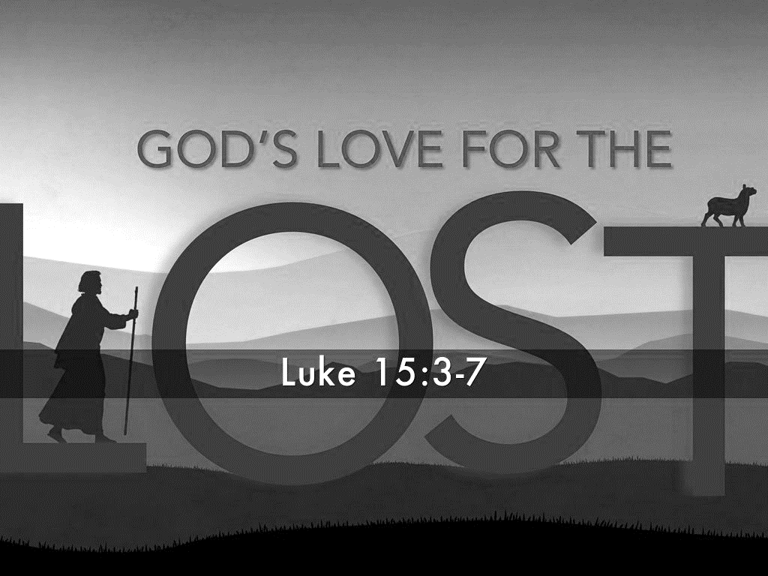

O N E > 99

