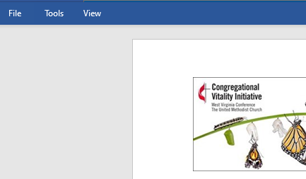
(You may have to click on the view option in the upper toolbar and select edit document to begin entering information in the form.)

Background Information:

Church/Charge Name:
District: |  | Select District
Conference Superintendent: |  | (Which conference superintendent does your church relate to?)  Choose an item.
Pastor’s Name:
Email:
Phone Number:
If awarded, checks will be made payable to the church/charge name listed above.
Address to  mail check: | Address:
 | City:
 | State:
 | Zip:

Submission Information:

Name of Submitter:
Church Position:
Email:
Phone Number:

Grant Request Information:

Type of Grant Request: | Select Grant Type
Grant Amount Request: | $

Supporting Documentation:

Please provide a detailed breakdown of the total cost of the project/program. Include an itemized estimate for the entire project/program, not just the portion for which grant funds are requested. Note: be sure that you have explained why the church needs a grant to cover this expense and why the church is not covering this expense within the normal budget process.

How will the grant funds be utilized?

How do you see these funds helping your ministry grow disciples and reach new people for God’s Kingdom?

Please attach/include the following three items from the umdata.org page for your church:
- Membership and Attendance chart
- Apportionment Percentage Paid chart
- A screen shot of the “Quick Facts” section

Submit your grant request to:

By Mail:
West Virginia Conference
Congregational Vitality Team
PO Box 2313
Charleston, WV 25328
Or by Email:
Chris Ridgway at cridgway@wvumc.org

