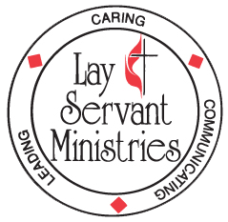
DISTRICT LEADERSHIP and LAY SERVANT ACADEMY

UPCOMING - 5-week class (Mondays, 6:30 PM – 8:30 PM)

Transforming Evangelism (Advanced Heritage class)

Taught by Pastor Cindy Boggs via Zoom and at First Church in Shinnston

Dates: August 3, 10, 17, 24, 31

This course leads participants to learn from John Wesley how to practice relational evangelism. They will discover that evangelism involves not only sharing our faith with others but also welcoming people into a community where they can grow in faith.

This is a small group study. Attendance at all five classes is required to receive credit if you are on the lay servant pathway. There is no charge for this class - you will need to purchase the text “Transforming Evangelism” by Henry H. Knight III and F. Douglas Powe, Jr. (ISBN-13 # 978-0881774856) on your own – it is available from Amazon in paperback and kindle format, and from Cokesbury (844) 291-7803. (Please allow plenty of time for delivery). Registration deadline is July 24th.

Questions regarding the course may be directed to Mary Bane at 304-692-0003 or by email to crazymcb1@gmail.com.

Send the completed form to: MonValley District UMC
309 Cleveland Avenue, Suite 100
Deadline is July 24th Fairmont, WV 26554

Transforming Evangelism 5 week course: Aug. 3 – 31, 2020 (Cindy Boggs)

PLEASE PRINT

Name:

Mailing address:

City: ____ State: Zip:

Home telephone: E-mail:

Local church: Pastor:

I have ordered my copy of “Transforming Evangelism”
I will attend via Zoom

Type of Study (Check one only)
( ) Self-Improvement ( ) Certified Lay Servant ( ) Certified Lay Speaker

