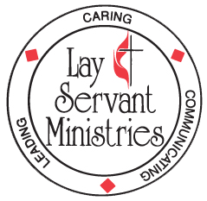
DISTRICT LEADERSHIP and LAY SERVANT ACADEMY

UPCOMING - 5-week class (Tuesdays, 6:30 PM – 8:30 PM)

Leading Worship (Advanced class)

Taught by Rev. Judy Flynn via Zoom

Dates: July 7, 14, 21, 28, and August 4

This course focuses on the ministry of the lay servant who either regularly or occasionally leads a group or congregation in worship.

This is a small group study. Attendance at all five classes is required to receive credit if you are on the lay servant pathway. There is no charge for this class - you will need to purchase the text “Worshiping with United Methodists” revised version by Hoyt Hickman (ISBN-13 # 978-0687335268) on your own – it is available from Amazon in paperback and kindle format, and from Cokesbury (844) 291-7803. (Please allow plenty of time for delivery). Registration deadline is July 1st.

Questions regarding the course may be directed to Mary Bane at 304-692-0003 or by email to crazymcb1@gmail.com.

Send the completed form to: MonValley District UMC
309 Cleveland Avenue, Suite 100
Deadline is July 1st Fairmont, WV 26554

LEADING WORSHIP 5 week course: July 7 – August 4, 2020 (Judy Flynn)

PLEASE PRINT

Name:

Mailing address:

City: ____ State: Zip:

Home telephone: E-mail:

Local church: Pastor:

I have ordered my copy of “Worshiping with United Methodists”

Type of Study (Check one only)
( ) Self-Improvement ( ) Certified Lay Servant ( ) Certified Lay Speaker

